How to Post a Job, Internship or Volunteer Experience in UMA CareerLink

- Go to https://uma-csm.symplicity.com/employers
- Enter your username (e-mail) and password (or sign up on the right side of the page)
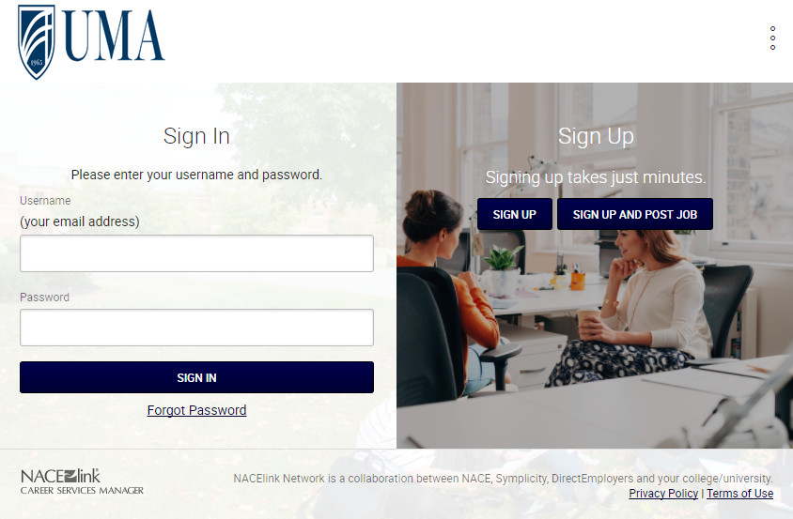

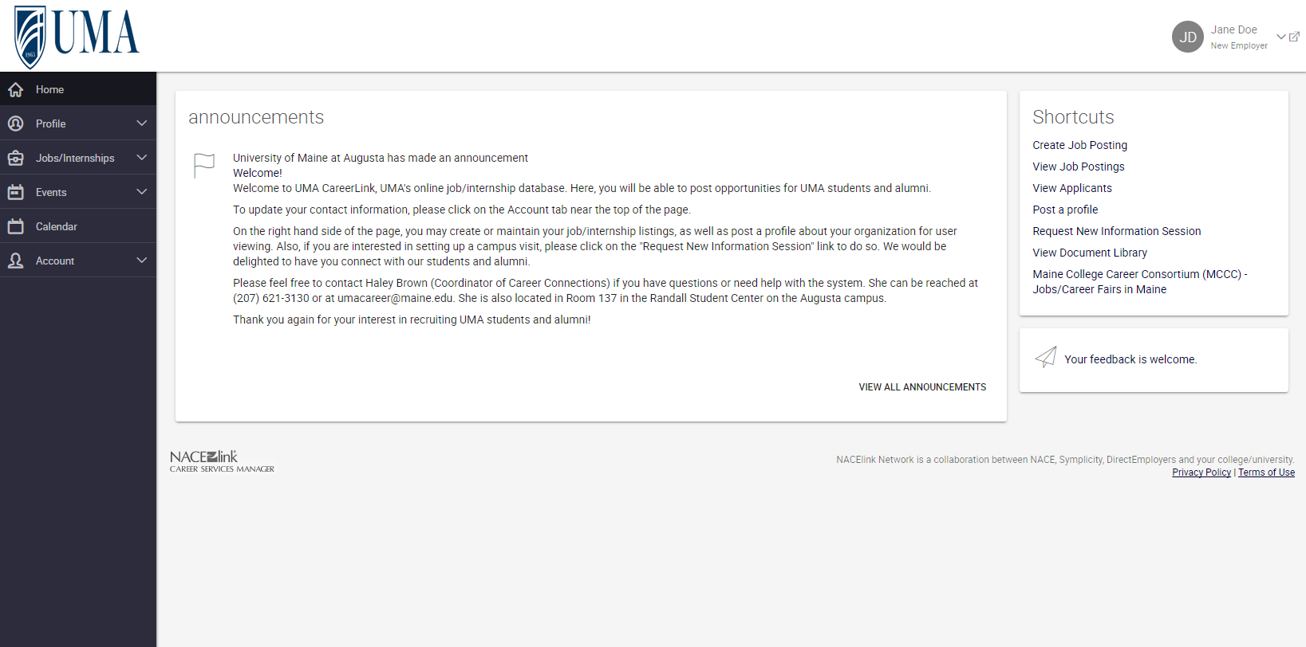
- You should now be logged into your Employer Homepage:

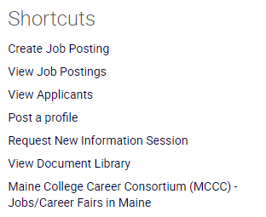
- On the top right of your Homepage, Locate Shortcuts, and click on “Create Job Posting”
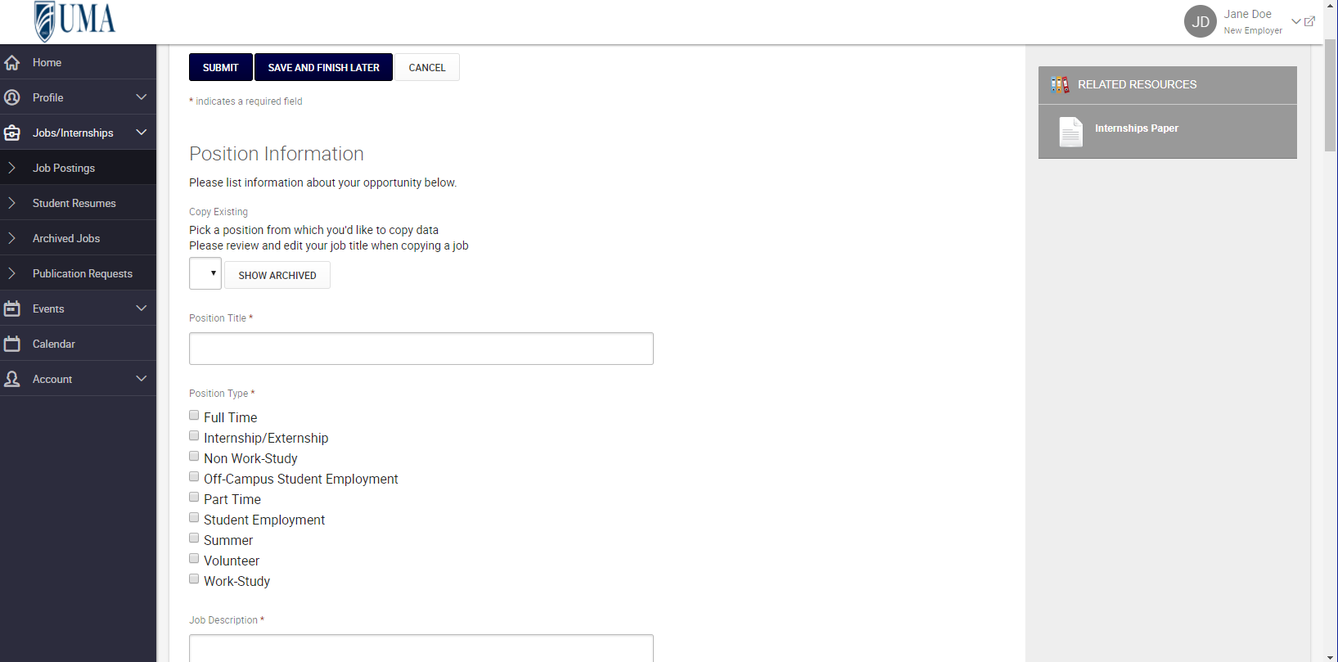
- Enter your Job/Internship/Volunteer Position and click SUBMIT!
- Your position will be reviewed by a Career Connections Staff Member within two business days. We will reach out to you if we have questions about your posting.

If you have any questions or need assistance, please contact the Career Connections Office:
207.621.3130 | umacareer@maine.edu
http://www.uma.edu/academics/advising/career-connections/

